Assignment 6

Name: Lukas Pfalz

ITS 1110

Section: CSC-1110-71762

# **Assignment 6**

***COMPLETE THE HONOR CODE BELOW***

**HONOR CODE:**

I pledge that this program represents my own program code, I have received help from no one and I have given help to no one.

**OR**

I received help from **NAME OR NO ONE** in designing and debugging my program.

I have given help to **NAME OR NO ONE** in designing and debugging my program.



This assignment is required.

The grading form shows point values for this assignment. Please review it now.

Show screen shots of the python code with comments and your input/output window.

You should use several well-planned sets of data to check out your program. Testing your programs with just the data that is asked for in the assignment does not necessarily mean that the programs will work for all cases.

Please include the following comments in each of your Python programs:

Your Name

Section

Date

Description

Assignment Number

A python template (python_template.py) has been provided for you to use.

Name this document XXX_Assignment 6 where XXX are your initials. Include a python file named P01.py, P02.py, etc. for each problem.

## Write a program that takes a list of numbers from 1 to 10 and splits that list into two separate list. One list for the numbers that are odd and the other for those that are even. Do not hardcode your lists, other than the original list. Hint: You should use an if-else statement to determine which list each number should go to.

Here is the lists the list of numbers:

#lists of numbers

numbers_list = [1, 2, 3, 4, 5, 6, 7, 8, 9, 10]

Here's the sample program you are to run:

Original List: 1, 2, 3, 4, 5, 6, 7, 8, 9, 10

Even list:

Odd list:

Comment your source code and describe your code to someone who may be viewing it for the first time.

**PLACE SCREEN SHOTS OF THE PYTHON CODE AND ALL I/O BELOW.**

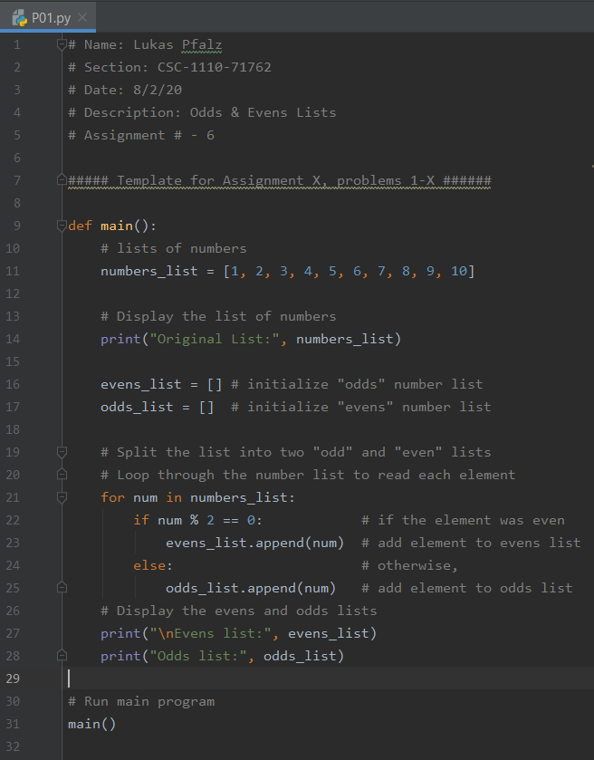

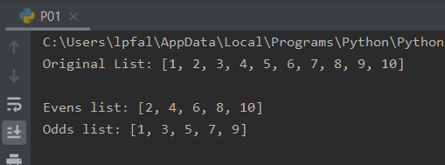

Fast Food Restaurant

Note: The programs you will be writing for Part2a through Part 2f build on one another. You will want to attempt these parts in order. You can also feel free to save all of your work in one big file but remember to show screenshots of each part.

## Imagine that you are helping to build a store management system for a fast food restaurant. Given the following lists, write a program that asks the user for a product name. Next, find out if the restaurant sells that item and report the status to the user. Allow the user to continually inquire about product names until they elect to quit the program.

Here are some lists to get you started:

# product lists

product_names = ["hamburger", "cheeseburger", "small fries"]

product_costs = [0.99, 1.29, 1.49]

Here's the sample program you are to run:

(s)earch for product or (q)uit: s

Enter a product name: hamburger

We sell "hamburger" at 0.99 per unit

(s)earch for product or (q)uit: s

Enter a product name: salad

Sorry, we don't sell "salad"

(s)earch for product or (q)uit: voldemort

Invalid option, try again

(s)earch for product or (q)uit: q

See you soon!

Comment your source code and describe your code to someone who may be viewing it for the first time.

**PLACE SCREEN SHOTS OF THE PYTHON CODE AND ALL I/O BELOW.**

## 

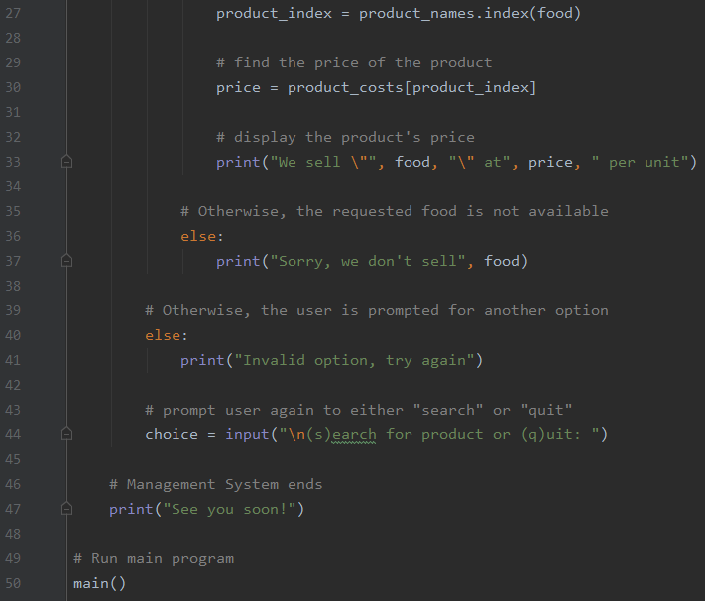

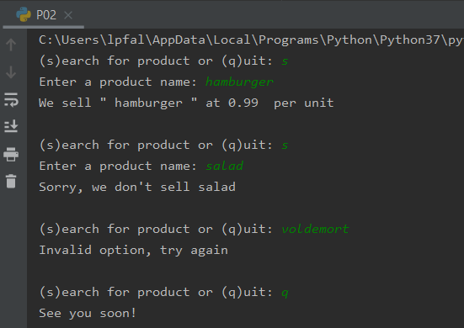

## You have been asked to write a username validation program for a small website. The website has specific rules on what constitutes a valid username, including:

* All usernames must be between 8 and 15 characters long
* Usernames can only contain alphabetic (a-z and A-Z) and numeric characters (0-9) - no special characters are allowed.
* The first character in a username cannot be a digit
* Usernames must contain at least one uppercase character
* Usernames must contain at least one lowercase character
* Usernames must contain at least one numeric character

Write a program that asks the user to enter in a username and then examines that username to make sure it complies with the rules above. Here's a sample running of the program - note that you want to keep prompting the user until they supply you with a valid username:

Please enter a username: foo

Username must be between 8 and 15 characters.

Please enter a username: fooooooooooooooooooo

Username must be between 8 and 15 characters.

Please enter a username: foo ooo ooo

Username must contain only alphanumeric characters.

Please enter a username: foooooooooo

Your username must contain at least one digit

Please enter a username: 1fooooooooo

The first character in your username cannot be a digit

Please enter a username: fooooooooo1

Your username must contain at least one uppercase character

Please enter a username: Fooooooooo1

Your username is valid!